CodePanorama: a language agnostic tool

for visual code inspection

Paper doi: <https://dl.acm.org/doi/10.1145/3524610.3527874>

Team members: Ciama Andreea Elena, Abrudan Rebeca Rafaela

**Tool description**

CodePanorama: a language agnostic tool for visual code inspection. In contrast to reductionistic metrics, CodePanorama generates zoomed-out images (so-called code panoramas) of the entire selected code-base of a software project, thereby allowing the reviewer to take advantage of their innate image processing skills to instantly get a good first impression of thousands of lines of code. CodePanorama takes code from a Git repository and produces interactive images by generating a line of pixels for each line of code. This abstraction generates a “zoomed-out” view of the code.

**Installation**

CodePanorama is publicly available as a web application. Therefore, there is no need to install anything locally to analyze a project. <https://codepanorama.io>

**Project**

The tool was used on the program from the laboratory **Teacher Monitoring App Review for Requirements(Maven).** Te source code: <https://github.com/Andreea-Ciama/SSVV.git>

**Use of application**

You just need to paste the github URL and to write the name of the branch, in our case, main. And then you need to click on “Analyze”

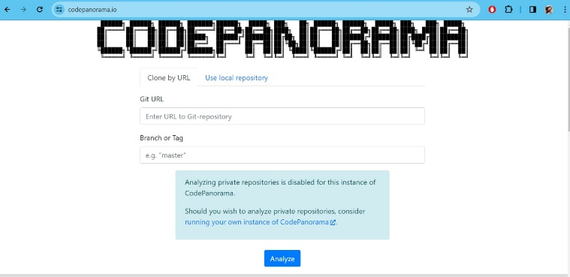

Now we are in the “filters” page. Here you can choose how the panorama will look, what file do you want to include/exclude. And then you click on “Generate Panorama”

Now you can check out the panorama and can change the color of it and you have some types of overlays to choose from. You can also choose to dowload it and it will be in a .tar document